
Contact

Send you Cv’s to job@mazco.com.sa

Or

Post Box: 2486, Dammam 31451,
KINGDOM OF SAUDI ARABIA.
Tell: +966 3 8260080 EXT: 31
Fax : +966 3 8266618
Website::www.mazco.com.sa

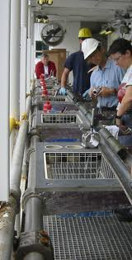
JOB DESCRIPTION
Lab Specialist Shall
- Capable of handle Rubber compound machine (two roll mill and Banbury on Pilot Scale) and train the people.
- Demonstrated ability in Rubber compound testing and physical property testing.
- Ability to work on rubber injection, Profile extrusion and compression moulding machines and autoclave on pilot scale.
- Perform calibration, preventive maintenance and checking.
- Perform assigned test/ requests on timely and quality basis ensuring the housekeeping and safety practice
- Comply with safety regulations.
- Analyse and report test results.
- Effective communication skill in English.
- Report any abnormalities in the Section.

QUALIFICATION
- Bachelor Degree in Chemistry
- Minimum Experience of 7 years.
- Good interpersonal skills and encourage team work.
- Effective verbal and listening communication skills
- Skilled in MS office and other statistical software
- Report and resolve issues if any with the concerned sections.
- Knowledge in Laboratory Experiments.

Lab Specialist

